Private Company
Management Liability Insurance
Proposal

Prepared for:

ABC Company

Presented by:

EPIC Insurance Brokers & Consultants

In collaboration with:

RT ProExec

June 2022

Table of Contents

            - Introduction
            - Proposal
            - Marketing Summary
            - Insurance Application
            - Avoiding Friction

Appendices
- Policy Structure
- Coverage Discussion, Exposures, Peer Purchasing Data and Claims Examples


I. Introduction
Thank you for the opportunity to provide you with a private company Management Liability Insurance (MLI) proposal. We have detailed your MLI proposal in the following pages. Section II provides details regarding the terms and conditions received from AXIS and Section III provides a synopsis of the responses received from the marketplace. Section IV provides a discussion of several key policy terms and items to consider when completing the application. Section V provides advice to help you avoid unnecessary problems. The proposal concludes with two Appendices; Appendix A outlines the mechanics of a typical MLI policy and Appendix B provides an outline of the coverages and exposures to loss, as well as peer limits purchasing data and claims examples for each component coverage part of such a policy.
We appreciate the opportunity to be of assistance to ABC Company regarding your Management Liability Insurance needs and look forward to discussing our proposal with you in further detail.

II. Proposal
Private Company Management Liability Insurance Proposal
Insurer: AXIS Insurance Company – Admitted
Rating: A.M. Best: A “Excellent” FSC: XV

Form: Privatus Platinum Policy, GTC AXIS 1010502 0720
Defense: Duty to Defend
Effective: TBD
Discovery: 1 year at 100%, 2 years at 125% or 6 years at 150% on a bilateral basis Continuity: Inception

Limits of Liability and Total Premium
Separate Limits of Liability (per Claim and in the Aggregate) Premium
$1,000,000 Directors & Officers Liability Limit $25,000
$1,000,000 Employment Practices Liability Limit
$1,000,000 Fiduciary Liability Limit

Liability Retentions per Claim
$0 each D&O Claim for non-indemnifiable Loss
$50,000 each D&O Claim for indemnifiable or entity Loss
$25,000 each EPL or Third Party EPL Claim
$0 each Fiduciary Claim

Additional Coverage Terms
$500,000 Additional A-Side Limit of Liability
$100,000 Securityholder Derivative Event Expense
$1,000,000 Employed Lawyers Liability Sublimit
$100,000 Insured Inquiry Event Expense
$100,000 Training Expense Limit (subject to 15% coinsurance)
$50,000 IRCA (“Immigration”) Event Expense Limit
$50,000 WARN Act Expense Limit
$250,000 Sublimit for each of the following: ERISA Penalties; HIPAA Penalties; IRC Tax Penalties; Pension Protection Act Penalties
$250,000 Voluntary Correction Expense Limit

Crime Coverage Detail – Loss Discovered Basis premium included above
Insuring Agreement Limit Retention*
Theft of Insured Entity’s Property $1,000,000 $25,000**
Theft of Client’s Property $1,000,000 $25,000
Forgery of Negotiable Instruments $1,000,000 $25,000
Legal Expense $100,000 N/A
Forgery of Payment Card Instruments $1,000,000 $25,000
Inside the Premises $1,000,000 $25,000
In Transit $1,000,000 $25,000
Money Order or Counterfeit Currency Fraud $1,000,000 $25,000
Computer Transfer Fraud $1,000,000 $25,000
Restoration Expense $100,000 $0
Funds Transfer Fraud $1,000,000 $25,000
Social Engineering Fraud $100,000 $25,000
Investigation Expense $100,000 $0
*Retention per Claim
**No retention applies to Loss of any ERISA Plan.

Contingencies
This quote is subject to carrier’s acceptable review of the items below, PRIOR to binding:
- Signed and dated application.

Forms and Endorsements

- AXIS 104 0415 State Fraud Statement (General Terms)
- AXIS 906 0316 Policyholder Notice – Economic Trade Sanctions (General Terms)
- TRIA DISCLOSURE 0115 Policyholder Notice of Terrorism Insurance (General Terms)
- AXIS 1010502 0720 AXIS Privatus Platinum General Terms and Conditions
- AXIS 1010504 1016 AXIS Privatus Platinum Employment Practices Liability Coverage Part
- AXIS 1010506 1016 AXIS Privatus Platinum Fiduciary Liability Coverage Part
- AXIS 1010507 0720 AXIS Privatus Platinum Crime Coverage Part
- AXIS 1010538 1117 Insured Executive Amended Endorsement – CEO, CFO, GC (General Terms)
- AXIS 1010569 1016 Settlor Acts Coverage Endorsement (Fiduciary Coverage)
- AXIS 1010594 1117 Amend Exclusion Endorsement – Amend BI/PD and Professional Services Exclusion from “based upon or arising out of” to “for” wording (D&O Coverage)
- AXIS 1010631 0618 Amend Spousal Condition Endorsement to include family trusts (General Terms)
- AXIS 1010632 0618 Named Insured’s Right to Cancel Coverage Part Endorsement – Affirmatively states the Insured can cancel any Coverage Part and purchase an optional Extended Reporting Period in the event of a Change in Control and any unearned premium will be credited against the cost of the ERP; pre-agreed run-off pricing of 1 year at 100%, 3 years at 125%, or 6 years at 150% (General Terms)
- AXIS 1010634 0618 Amend definition of Claim to include indictment or information, arrest or confinement warrant, or similar charging document against, or request for extradition of, an Insured Individual by any Governmental Authority (Fiduciary Coverage)
- AXIS 1010718 1117 Employed Lawyers Liability Sublimit of $1,000,000 subject to [purchased] Retention (D&O Coverage)
- AXIS 1011040 0817 Cap on Losses from Certified Acts of Terrorism (General Terms)
- AXIS 1011075 1018 Public Relations Expense Coverage Endorsement - $X sublimit (D&O Coverage)
- Amend definition of Event to include Crisis Event
- Crisis Event includes Publication of the following under the Management and Entity Liability Coverage Part:
  - The Insured’s product or service causes injury to a group of people
  - The Insured defaulted or restructured its debt
  - A voluntary or involuntary Bankruptcy petition
  - The layoff of 25% or more Employees
  - The death resignation of the President or CEO
  - Litigation commenced against the Insured by a Governmental Authority
- Crisis Event does not include any Publication related to pollutants or nuclear materials
- AXIS 1011699 1018 Amend Definition of Defense Costs to include reasonable expenses of an electronic discovery consultant to develop processes and technologies for identification, collection, and production of electronically stored information for use in a covered claim (General Terms)
- AXIS 140 0815 Application Reliance Endorsement
- AXIS 1010540 1016 Insured Inquiry Event Expense Coverage Endorsement - $X sublimit for a subpoena or other request by any Government Authority for the Insured Entity to appear for an interview or meeting, provide testimony, or produce personal documents in connection with a proceeding or investigation by such Government Authority, including but not limited to a proceeding or investigation pursuant to the UK Corporate Manslaughter and Corporate Homicide Act (D&O Coverage)
- AXIS 1010633 0618 Carveback to ERISA Exclusion for Non-Indemnifiable D&O Claims (D&O Coverage)
- AXIS 1011700 0618 Coverage for costs incurred by the Insured Entity in excess of normal operating costs to respond to a written investigation by the SEC or similar Government Authority – $X Sublimit subject to $X Retention (D&O Coverage)
- AXIS 141 0915 State Amendatory Inconsistency Endorsement
- AXIS 1010541 0618 IRCA Event Expense Sublimit of $X subject to [purchased] Retention (EPL Coverage)
- AXIS 1011046 0817 Pension Protection Act Penalties Endorsement – $X Sublimit
- AXIS 1011713 0618 Coverage for attorney fees and expenses for the Insured Entity to defend or settle a civil complaint for monetary relief due to an actual or alleged violation of Worker Adjustment and Retraining Act or any similar law, subject to Sublimit of $X and [purchased] Retention (EPL Coverage)

The description of policy terms in this document is only a summary. Please note that the actual policy language, including endorsements, will dictate the scope of coverage in the event of a claim. We encourage you, with the assistance of legal counsel, to read the full policy form and applicable endorsements in order to have a better understanding of its terms and conditions. We further encourage you to raise with us any coverage issues that are of particular importance and which may not be specifically addressed in our written materials.

III. Marketing Summary
Carrier | A.M. Best Rating | Carrier Response
AIG | Excellent A XV
AllDigital Specialty | Excellent A XV
Allied World | Excellent A XV
Arch | Superior A+ XV
AXIS | Excellent A XV
Berkley Select | Superior A+ XV
Chubb | Superior A++ XV
CNA | Excellent A- VIII
E-Risk | Superior A+ XV
Great American | Superior A+ XV
Hanover | Excellent A XV
Hiscox | Excellent A XV
Hudson | Excellent A XV
Intact (fka OneBeacon) | Superior A+ XV
Ironshore | Excellent A XV
Markel | Excellent A XV
Navigators/Hartford | Superior A+ XV
Nexus | Excellent A IX
Philadelphia | Superior A++ XV
QBE | Excellent A XV
RLI | Superior A+ XII
RSUI | Superior A+ XIV
Skyward | Excellent A- IX
Sompo | Superior A+ XV
Starr | Excellent A XV
Tokio Marine HCC | Superior A++ XV
Travelers | Superior A++ XV
Zurich | Superior A+ XV

IV. Insurance Application and Additional Terms

As part of the insurance acquisition process, insurance companies will typically require applicants to complete an insurance application, as well as provide additional and/or supplemental information. It is important to note that the term “Application” is usually defined in the insurance policy to include several categories of materials beyond just the physical application document – including any additional and/or supplemental information provided along with the application for insurance.
Also, management liability insurance (MLI) policies are "claims-made" policies, meaning that the policy only covers claims first made within the policy period. However, the alleged “wrongful act” underlying the claim can have occurred either during the policy period or prior to its inception. In order to have coverage for all previous wrongful acts, the policy must be written without either a Prior Acts Exclusion or a Retroactive Date. If a Retroactive Date is included in the policy, it must be backdated to provide a sufficient amount of retroactive coverage. Most modern MLI policies are written without a Prior Acts Exclusion or Retroactive Date, unless certain past events warrant such a coverage restriction, such as a change in control or serious claim situation.
Although “prior acts” may not be excluded, the carrier will specifically exclude matters disclosed in the company’s answer to the warranty statement in the application. When a company purchases management liability insurance (or adds additional / excess limits) for the first time, the company must represent and warrant to the insurer that no person or entity proposed for the insurance is aware of any fact, situation or circumstance that could lead to a claim. The wording varies somewhat among insurers, but the approach is universally referred to as a "warranty statement," and the objective is for the carrier to avoid insuring a “burning barn,” so to speak. It is too late to apply for liability coverage if you are already aware that a claim may arise in the near future. Any facts, situations or circumstances already known that might lead to such a claim should be disclosed and will be specifically excluded by the insurer. Care must be taken to provide a full and candid response to the warranty question, as any misrepresentation or omission can have serious implications should a claim arise out of facts, situations, or circumstances that should have been disclosed. We recommend that you poll your directors and officers individually to determine if they are aware of any facts, situations, or circumstances that should be disclosed in the warranty statement. We also recommend working closely on this issue with your insurance broker (and your legal counsel, if necessary).
In addition to the exclusion of any specific matters revealed in the application or warranty statement, every policy contains a Prior and Pending Litigation Exclusion or “P&P Lit” exclusion applicable to any litigation that occurred before, or is pending as of, the inception of the first policy term. It is important to note that the exclusion will also apply to a claim arising out of or related to any pending or prior litigation. The P&P Lit date with respect to a first-time purchaser of management liability insurance will be policy inception. Each time the insured adds a new excess layer of coverage, the P&P Lit date for each respective layer will match the inception date of the new layer.

In subsequent years, when an MLI policy is renewed with the incumbent insurer, at the same or lesser limit or scope of coverage, the policyholder is not required to repeat its warranty statement and the P&P Lit date remains the date on which the policyholder first purchased that level of coverage. If a company moves its MLI policy from one insurer to another, that transition should be as seamless as possible, and include continuity of coverage. To ensure that continuity is maintained, the replacement insurer must agree to do two things: (1) waive the requirement for an updated warranty statement from the insured and (2) use the P&P Lit date that was originally imposed for that particular level of insurance (commonly referred to as "backdating" the Prior and Pending Litigation Exclusion). When the replacement insurer does both things, the insurer is said to have provided full "continuity" of coverage. Note, when a client purchases management liability insurance for the first time, “continuity” is not an issue; this becomes a key factor at future renewals.
Importantly, any notice of claim or circumstance that could give rise to a claim made under an MLI policy will be excluded from coverage under any renewal or replacement of that policy. This is known as the Prior Notice Exclusion and is contained in every MLI policy due to the “claims-made” nature of the form. Again, an MLI policy only covers claims first made within the policy period. Whenever an insured is faced with a decision to move coverage from one carrier to another, it is always wise to consult with counsel before doing so to ensure that future coverage will not be jeopardized by the interplay of the knowledge warranty, the Pending and Prior Litigation Exclusion, and the Prior Notice Exclusion.

V. Avoiding Friction

Given our many years in the industry, we have observed a number of issues that seem to arise repeatedly that result in unnecessary friction between the insurer and the policyholder. In addition to negotiating and procuring the most competitive insurance program on your behalf as your insurance professional, we need to make you aware of these issues in order to avoid such friction. Understanding the following coverage terms and conditions, including policy mechanics, will assist you in avoiding unnecessary pitfalls. The below list of items is not intended to be an exhaustive list, but rather provide policy highlights that are important for insureds to bear in mind so that their policies can be utilized as effectively as possible.

DUTY TO DEFEND COVERAGE
Your policy contains provisions that govern the defense of covered claims. These provisions detail which party bears the responsibility to defend and direct the defense of a given claim. The majority of management liability insurance (MLI) policies are written on a “duty to defend” basis.
Under a duty to defend policy, the insurance company retains the right and duty to defend a covered claim once it is tendered to the insurer, regardless of whether the claim is groundless, fraudulent, or lacks merit. Further, in most cases where coverage is written on a duty to defend basis, the carrier will be obligated to defend the entire matter, even if certain allegations are not covered under the policy. This is the case where the policy provides “100% defense costs allocation” (frequently but not always available with duty to defend coverage). When the insurer bears the duty to defend, the insurer will select defense counsel from its list of panel firms to defend the insured. Again, the insurance company will select counsel – not you, the insured. It is important to note that any engagement with non-panel or unapproved counsel, and/or any defense costs incurred prior to properly reporting a claim to the insurer and coordinating with an assigned claims examiner, can result in claim costs not being covered. The insurer is under no obligation to cover “pre-tender” costs, and it can be very difficult, if not impossible, to negotiate an accommodation for such costs after the fact. It is incumbent upon you to abide by the policy terms and conditions to access the best coverage available under a duty to defend policy.

REIMBURSEMENT COVERAGE
While most MLI policies are written on a duty to defend basis, some are written on a reimbursement basis. Under a reimbursement policy, the insured retains the right and duty to defend a covered claim once it is noticed to the insurer. The insured may select its own counsel, but this selection is subject to approval by the insurer, and counsel must abide by the insurer’s billing practices (sometimes referred to as litigation management guidelines). Reimbursement of defense costs is relatively more complex under this approach, as the insurer will audit and often adjust defense counsel’s invoices, and where there are both covered and uncovered allegations or parties, the insurer will allocate defense costs among such allegations and/or parties from the onset of the claim. Still, some insureds (typically larger organizations with in-house counsel and well-established human resources departments) prefer taking on a more active role in managing the defense of claims, and sometimes seek out reimbursement coverage.

NOTIFICATION OF CLAIMS AND POTENTIAL CLAIMS
Management liability insurance (MLI) policies are a claims-made policies specifying that you, the insured, must provide prompt notice of a claim. Swift reporting of claims is the best way to ensure that you are in compliance with the policy’s notice requirements.
When to notify the insurance company? It is imperative that you notify your insurance broker and the insurance company as soon as you receive notice that an individual, entity or enforcement or regulatory agency intends to make a claim or has made, filed or commenced a complaint, charge, subpoena, investigation, demand, or request for alternative dispute resolution. These are some, but not all examples, of matters that could trigger a claim. When in doubt, notify your insurance broker and insurance company of any communication against your organization, its executives, or its employees indicating a demand or allegation. Of particular concern are administrative charges. For instance, if you have purchased employment practices liability insurance (EPLI), be advised that administrative charges are claims as defined in most EPLI policies. Such charges are issued by the U.S. Equal Employment Opportunity Commission (see the following page for an example) or similar state or local agencies. We strongly recommend that you report such charges to your insurance broker as soon as you receive them so that they may be forwarded to the insurance company to comply with their notice provisions. Even if you are not sure whether the matter triggers coverage, it is best to provide your insurance broker with the information so that they may submit to the insurance company for their evaluation.

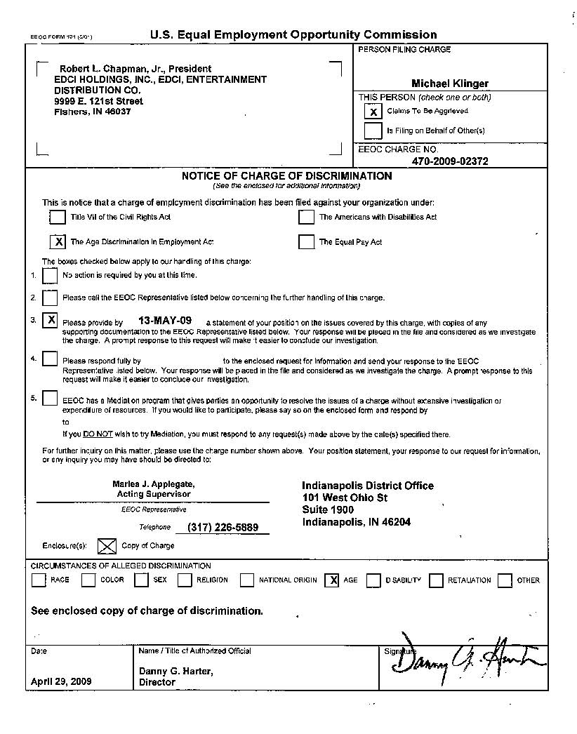

Finally, MLI policies also have strict provisions concerning the notice of potential claims. Failure to timely report a claim under the policy can jeopardize your eligibility for coverage on the basis of “late notice.” Providing prompt and accurate notice of a potential claim can preserve important rights for you under the policy. Please consult with your legal counsel or insurance professional to review the notice provisions in your policy.

SUBSIDIARIES, AFFILATES, AND ADDITIONAL INSUREDS
An MLI policy typically covers any entity that meets the policy definition of Subsidiary. Generally, such entities do not need to be listed on the Declarations Page or scheduled by endorsement. However, many privately held organizations have affiliated entities that share common ownership, and unless specifically added by endorsement, there is no coverage for an affiliated entity nor any of its directors, officers, managers or employees. Further, certain organizations create entities pursuant to contractual obligations that do not fall under the organizational ownership structure and are not covered Subsidiaries as defined by the policy. Upon request and receipt of additional information on affiliates or other entities not already contemplated for coverage, the insurer may be willing to list such entities via endorsement. Depending on the information provided, a premium may or may not be associated with the endorsement granting coverage for affiliated entities / additional insureds. Please note: Attaching a schedule of “Named Insureds” to an application will not result in coverage for any entity that does not meet the policy definition of Subsidiary. This must be specifically discussed and negotiated with the insurer.

ORGANIZATIONAL CHANGES

An organizational change should be promptly reported to your insurance broker and insurer to ascertain whether it triggers certain provisions within your policy.
The typical policy contains a “change in control” provision specifying how the policy will respond if the company is sold or sells substantially all of its assets. If the change in control provision is triggered, ongoing acts coverage will cease as of the close of the transaction and the premium becomes fully earned. The insured usually has the option to purchase a tail policy (also known as “runoff”), however it is important to provide notice of this election within the timeframe and in the manner prescribed by the policy.
Other provisions in the policy specify how the policy will respond if the insured entity acquires another entity with an asset, employee count, or plan asset size greater than a specified threshold. If an asset, employee count, or plan asset acquisition threshold contained in the policy is exceeded, you must notify the insurer in writing of the details of the new subsidiary. The insurer will then evaluate the acquisition to determine whether to extend coverage to the new subsidiary (as of the date of the acquisition), and whether to charge an additional premium to do so.
Further, there are notice requirements to be aware of if you conduct certain securities offerings, including an offering under Title III or Title IV of the JOBS ACT, or an Initial Public Offering. These scenarios will likely require a more extensive discussion with your insurance broker to evaluate the proper course of action.
To conclude, it is important for you, the insured, to provide your insurance broker with details of any organizational change so that we may provide guidance and engage insurers as needed to comply with the terms and conditions of your insurance program.

APPENDICES

Appendix A. Policy Structure

Management Liability Insurance (MLI) policies for privately held companies have evolved favorably since the modern introduction of the coverage line over 30 years ago. While an MLI policy can encompass several coverage lines, this discussion will focus on the three main types of insurance found in these policies: Directors and Officers Liability (D&O), Employment Practices Liability (EPL) and Fiduciary Liability. Each of these coverages is discussed in greater detail in the following pages.
The majority of modern MLI policies are written in a modular form consisting of a General Terms and Conditions (GTC) section, a Management Liability and Company Reimbursement Coverage Part (D&O), an Employment Practices Liability Coverage Part (EPL) and a Fiduciary Liability Coverage Part. The General Terms and Conditions section applies to all coverage parts and, as the section suggests, defines the general terms and conditions applicable to all coverage parts.
Insureds will generally be provided the option of having all three coverages share a single aggregate limit of liability or obtaining separate limits of liability for each coverage section. Whenever possible, we encourage insureds to purchase a policy with separate limits for the various coverages. A separate limit structure can prove invaluable in a multiple line claim situation, as payment under one coverage section will not deplete limits available under the other sections. A separate limit structure can be particularly valuable in a “meltdown” situation where a company spirals into bankruptcy. In such a scenario, staff reductions and layoffs could lead to EPL claims, funding problems for the retirement plans could spawn Fiduciary claims, and disgruntled creditors or shareholders could potentially file D&O claims. While this is admittedly a worst-case scenario, it does illustrate the importance of the separate limit structure. Please note that although some policies provide for separate limits, a common claim that exhausts multiple coverages may only expose a single aggregate limit.
The following section further describes each line of coverage available via a management liability policy, along with claims examples and peer purchasing data.
Appendix B. Coverage Discussion, Exposures to Loss, Peer Limit Purchasing Data and Claims Examples

Directors and Officers Liability Insurance

Directors and Officers Liability Insurance (D&O) combines three distinct coverages within one policy form. The first, often referred to as Non-indemnifiable or “A-Side” coverage, pays the covered loss of the individual directors and officers in situations where the company may be unable to indemnify them. As an example, a company may be prohibited from indemnifying its directors and officers due to public policy, or may be unable to meet its indemnification obligations due to financial insolvency. A-Side coverage typically applies on a “first dollar” basis (i.e. no deductible applies), unless specific state insurance laws dictate otherwise.
The second - or “B-Side” - coverage available under a D&O policy reimburses the company for its indemnification obligations to its directors and officers pursuant to its charter, by-laws or other contractual arrangements.
Finally, the policy also provides direct protection for the company itself under the “C-Side” or “Entity” coverage insuring agreement. The addition of entity coverage has proven to be a strong benefit to insureds, as it negates the contentious allocation issue that arose when claims were made against both covered directors and officers and uncovered corporate entities.
It is important to note that D&O insurance is by no means a commodity product; there are many insurance companies offering this coverage and each utilize their own proprietary policy forms that - apart from the basic insuring agreements - contain unique terms and conditions. Each policy must be reviewed individually and tailored as necessitated by the risk profile of a specific insured.
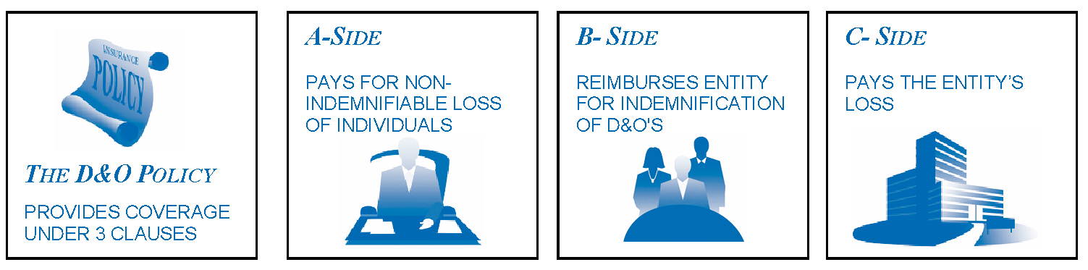
D&O Exposures and Claims

Directors and officers of privately held companies are wise to be cognizant of their corporate governance responsibilities. It is a common misconception that regulatory enforcement with respect to securities is limited to publicly traded companies. Private companies, like public companies, are subject to oversight by the Securities and Exchange Commission. In fact, the SEC has authority to investigate all companies that seek to raise capital from U.S. investors. Executives of privately held companies can be held liable for statements or other actions made in violation of the federal securities laws. A high-profile example involved the SEC enforcement action (and subsequent criminal proceedings) brought against the medical testing company, Theranos, and its directors and officers. The SEC and Department of Justice have also exhibited a willingness to scrutinize Silicon Valley “unicorns” (private companies with a valuation in excess of $1 billion). Further, while Sarbanes-Oxley standards are largely directed at public companies, some of the Act’s changes apply to all companies, public and private. In many contexts, directors and officers of privately held companies are expected to manage with a diligence similar to that of their counterparts at publicly traded companies. This is all to underscore that executives of privately held companies can draw the attention of regulators and are often subject to exacting corporate governance standards.
Unfortunately, privately held companies often lack the financial wherewithal of public companies and struggle to bring adequate resources to bear when issues arise. This can lead to potential liabilities for management. Directors and officers almost always have promises of broad indemnification from the companies they serve. However, given their relatively lesser financial resources, the possibility of a private company running out of money and not being able to honor its indemnification obligations is much greater than in the public company context. As the D&O policy is structured to provide coverage for non-indemnifiable loss on a first dollar basis, it can become the first and only line of defense if things go awry at a privately held company.
As a side note, there is growing awareness of and scrutiny surrounding companies’ “ESG” factors, driving increased pressure on organizations (whether privately held or publicly traded) to prioritize environmental, social and corporate governance in their operations and performance.

PRIVATE COMPANY DIRECTORS & OFFICERS LIABILITY
Limit of Liability Distribution for RT ProExec Placements Q1, 2022
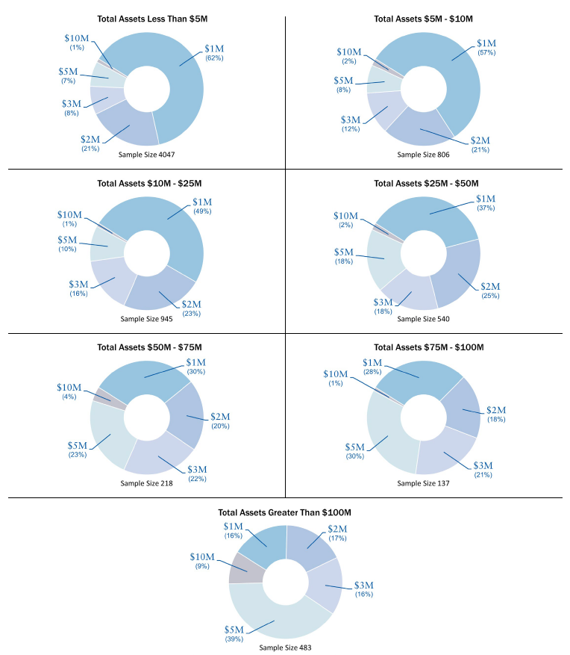

SAMPLE D&O CLAIMS (as provided by E-Risk Services)
Dilution Five founders of the company who once owned 40% of it allege that through the years a group of venture capital firms assumed management and engaged in a series of self-interested and dilutive stock offerings under terms that were grossly unfair to the common shareholders which resulted in them receiving less than $50k from a $80 million merger.
Defense Costs exceeded $250,000.

Business Partner A company chose not to renew a contract with its supplier due to bad blood between the parties. The company thought that the supplier was overcharging them and considered them to be thieves. In response, the company allegedly used information gained in an audit of the supplier to start up its own competing venture which then supplied both this company and others in the industry with competing products. The supplier alleged defamation/business disparagement, negligence, fraud and civil conspiracy among other allegations.

Defense of this claim exceeded $1 million.

Federal Investigation Federal agencies conducted a formal investigation into the activities of a defense contractor for the armed services. They investigated the company and its owner / president for alleged overbilling of the government for labor, improperly charging their lobbying costs into the contracts, and also for allowing foreign nationals to work on certain government contracts in violation of The International Traffic in Arms Regulations.

The defense was successful in convincing the federal agencies to drop their investigation and not to commence a civil or criminal lawsuit against either party.

Defense costs approached $500,000.

Misrepresentation in Sale of Company; Run-Off Claim A few months after purchasing an Insured Company and while the account was in Run-Off, the purchaser filed suit against the Company and its former directors and officers for alleged fraud and conspiracy to commit fraud. The plaintiff alleged that prior to the sale, the defendants conspired to withhold crucial information regarding deficiencies in one of the Company's products causing the plaintiff to greatly overpay for the Company.

Settlement and defense exceeded $2 million.

Family Shareholders After the death of a part owner of a company and his shares were bequeathed to his children, those children/shareholders noticed that their share of the profits was drastically reduced from what their father was receiving while he was still alive. The children alleged breach of fiduciary duty, conspiracy and fraud against the directors and officers. Specifically, they alleged that once the directors and officers were no longer under the watchful eye of their father, they allegedly began to drain the profits of the company through self-dealing, large personal purchases and other unscrupulous activities.
Defense and settlement exceeded $500,000.

Investor Fraud A company that provides medical billing services to a certain client is paid a set percentage of the amount it bills. A Medicare audit of the client determines that over a $1 million worth of services was improperly billed to it. The client is forced to repay Medicare and the company is forced to repay the commissions. While this investigation is going on, the company conducts a round of financing but fails to mention that its cash flow could be greatly hindered should it be required to repay the commissions. An investor in that round of financing alleges breach of fiduciary duty and fraud when the company is incapable of paying interest on the security.
Settlement and defense exceeded $250,000.

Investor An investor in a startup night club alleges misrepresentation, breach of contract, breach of fiduciary duty and unjust enrichment stemming from the failure of the company to pay him the proper profits from the venture. The investor alleges that the directors and officers diverted the profits out of this venture and into their own.

Settlement and defense exceeded $500,000.

Sale of Assets & Bankruptcy A competitor who successfully bid for the assets of a bankrupt company and the bankruptcy trustee both allege breach of fiduciary duty and fraudulent transfer by certain directors and officers in that they used company funds to purchase personal real estate, paid well above market rates for office space in a building owned by directors and officers, and improperly transferred other assets out of the company including its intellectual property which they then used to start up a similar venture.
Settlement and defense approached $750,000.
Joint Venture Claimants allege that a director/officer had been diverting funds for his personal use from $12 million borrowed in a joint venture with the Insured to rebuild a medical facility. Without enough money to finish the project, the bank foreclosed. The claimants alleged breach of the operating agreement, breach of fiduciary duty and negligence.
Settlement and defense approached $2 million.
Breach of Fiduciary Duty A shareholder who invested over four million dollars in a land management company files a complaint against the company and its directors and officers alleging breach of fiduciary duty, conspiracy and fraud. In particular, it is alleged that the company (insured) failed to make quarterly distributions, wrongfully transferred funds out of certain properties and participated in sham transactions to the detriment of all shareholders.
Settlement and defense exceeded $1,200,000.

Creditor Claim Plaintiff filed a complaint against individual directors and officers of a company alleging that its CEO, CFO, & COO conspired to use the plaintiff’s services to furnish, install and repair the company’s equipment knowing that it was insolvent and was planning to file for bankruptcy protection. Causes of action included: (1) fraud, misrepresentation and non-disclosure; (2) deceptive trade practices; and (3) civil conspiracy.
Total settlement and defense of the individually named defendants exceeded $100,000.
Class Action Complaint Plaintiffs represents a class of non-insider stockholders who invested in the company. Plaintiffs allege that certain directors and officers failed to disclose material facts and provided them with inaccurate and misleading information. It is alleged that the materials did not disclose the high turnover of management and that the company’s website had not yet been developed. The company later went bankrupt. The complaint included causes of action for: (1) common law fraud; (2) negligent misrepresentation; and (3) breach of fiduciary duties.
Settled for over $1 million and defense costs exceeding another $1.4 million.
Conspiracy & Negligence A professional wrestler who competes in a wrestling circuit files a complaint against the organization - and its directors and officers - which procures the talent for individual events across the country. Plaintiff alleges that he was excused by the organization from appearing at an event due to an illness in his family. The organization allegedly deemed that he was not properly excused pursuant to its rules and was suspended for a period of over one year. Plaintiff alleges that the suspension was done in an arbitrary manner and violated his contract. Plaintiff further alleges that his suspension was done in a conspiratorial manner in order to stifle competition. The plaintiff alleges the following causes of action: (1) breach of contract; (2) negligence; (3) fraud; (4) interference with prospective economic advantage/business relations; (5) conspiracy; (6) and intentional/reckless infliction of emotional distress. Plaintiff is not an Employee as defined by the policy.
The matter is currently being defended and defense costs have exceeded $200,000.
Dispute Over Inventorship An inventor filed a complaint against a research and development company specializing in medical devices alleging that the company was founded by his former partner for the purpose of stealing his highly valuable and uniquely innovative technology. This technology was the subject of a patent application which listed the plaintiff as the sole inventor. Plaintiff's former partner, in charge of securing the patent, allegedly informed the plaintiff that he must also be listed as a co-inventor for the patent to be filed. When the plaintiff refused, his former partner withdrew the application. With the partnership subsequently liquidated and the application abandoned, the former partner immediately formed a new company and filed a new patent application virtually identical to the plaintiff's but listed the former partner as the sole inventor. In his complaint, plaintiff alleges that the company and its director/officer (his former partner) misappropriated technology that he developed, and utilized it to establish the research and development company. Plaintiff asserts causes of action for: (1) fraud; (2) negligent misrepresentations; (3) breach of fiduciary duty; (4) conversion; and (5) successor liability.
Defense and settlement of this matter exceed $1 million.
Competitor Disputes The plaintiff filed a complaint against their competitor alleging that a former employee, now working at the competition, engaged in unauthorized use of confidential and proprietary information and committed other acts of unfair competition. As a result, the plaintiff alleges it has suffered irreparable and immediate injury. In addition, the plaintiff alleges that the defendant has possession of its confidential information and intellectual property. The plaintiff asserts causes of action for: (1) misappropriation of trade secrets and confidential information; (2) violation of the Computer Fraud and Abuse Act (3) unlawful access to stored information; and (4) unfair competition. The plaintiff seeks: (1) attachment of a computer server; (2) attachment of certain files and documents; (3) injunction – preservation; (4) injunction – proprietary information; (5) injunction – surrender of possession; (6) injunction – non-compete; (7) compensatory damages; (8) exemplary and punitive damages; and (9) attorneys’ fees and costs.
Total defense costs and settlement exceeded $350,000.
Shareholder The plaintiff alleges that certain directors have exerted complete domination and control over the company and used the company as a vehicle for their own business purposes at the expense of the company and minority shareholders. Specifically, the plaintiff alleges that certain directors helped to renegotiate a service contract and booked all of the revenue during one quarter instead of over the three year life of the contract. The plaintiff also contends that this service contract received steep discounts and would cause other customers to request similar discounts resulting in lost revenue to the company.
The defense and settlement of this case exceeded $500,000.

Misappropriation of Trade Secrets A wholesale supplier and distributor of food products meets with a sales representative of a new product line they are considering. The sales representative communicated that in order to develop a long-term exclusive relationship within the designated territory, the wholesaler must provide her with information regarding its business operations, customers, and trade secrets. Later on, the sales representative opened her own wholesale distributorship within the same territory.
This claim is currently being defended and defense costs have exceeded $450,000.

Breach of Investment Agreement A company enters into an investment agreement with a third party and agrees not to negotiate with other entity regarding financing or a potential acquisition for a two-week period. During the exclusivity period the company engages in negotiations with another investment group. The third party alleges breach of investment agreement and intentional and negligent misrepresentation.
Total defense costs and settlement exceeded $350,000.
Shareholder Derivative Action A shareholder derivative action is taken against a company for breach of fiduciary duties on behalf of the directors. The plaintiffs contend that the defendants have failed to provide them with certain information, such as shareholder listings, financial data and other corporate records. They also allege that certain directors borrowed money from the company without the Board’s approval and subsequently these loans were forgiven.
Total defense costs and settlement exceeded $500,000.
Breach of Fiduciary Duty A private company agrees to perform market research for a start-up company in the material management industry. In exchange for their services, the company allegedly agrees to pay the private company $20,000 in cash and 5% of the privately placed issued shares in the company. The company denies that they explicitly or implicitly agreed to pay the private company in stock. The plaintiffs allege several causes of action, including breach of fiduciary duty.
Total defense costs and settlement exceeded $800,000.
Government Agency The federal government sued the CEO, the President and other officers of an East Coast manufacturing company for price fixing.
After an extensive trial, the allegations were dismissed due to lack of circumstantial evidence, but the defense costs and fees incurred were in excess $750,000.
Misrepresentation/Deceptive Trade Practices A private software company represents that it can write software for a major corporation according to the corporation's specifications; provide maintenance services for four years; and execute updates and upgrades to the software. The private company misses key delivery dates. The software fails key functionality tests and ultimately crashes and becomes inoperable. The corporation decides to withhold payments until certain milestones are met. The private software company allegedly indicates to the corporation that it needs the payments in order to remain solvent. The plaintiff alleges that the private software company represented that it could produce the software and that it was a financially stable company. The plaintiff alleges the following causes of action; misrepresentation and deceptive trade practices; and breach of covenant of good faith and fair dealing.
Total defense costs and settlement exceeded $1,000,000.

Deceptive Trade Practices A private company that manages and runs a major natural resource receives a claim against the company and various members of the board of directors. The plaintiff alleges that the board of directors have used their position for their own private benefit and personal advantage, and for the benefit and advantage of their private employers. The plaintiff also alleges that the board of directors assigned a valuable contract without receiving any consideration. The plaintiff further alleges that such assignment also constitutes misappropriation of valuable assets for the benefit of private party in violation of state codes.
Total defense costs exceeded $250,000.
Inaccurate Disclosure A class action suit was commenced by various investors who participated in an internet startup company’s Private Placement that raised in excess of $5 million to fund capital expenses, to provide working capital and to cover operating losses. An investigation made by and through counsel, primarily from corporate records and public records and documents shows that the Private Placement Memorandum contained an unaudited year-end balance sheet and statement of profits and losses which were materially misleading.
Total defense costs and settlement exceeded $500,000.
Loan Default A diversified sports product company received a lawsuit against the President, CEO, and Chairman of the Board for not honoring a promissory note. The plaintiff alleges that it lent $1 million to the company. The company allegedly agreed to pay the funds back within a month pursuant to the promissory note. Despite requests for return of the money, plus interest, the company has not returned the funds to the plaintiff.
Total defense costs and settlement exceeded $250,000.

Inadequate Financial Reporting A technology company received a complaint from an investor who alleges the company improperly induced the plaintiff to issue a note payable to the company. The plaintiff specifically alleges the company made false representations and other false statements regarding the company’s forecasted rate of growth and failure to disclose its tax lien.
The company defaulted on the promissory note when it failed to make the required principle and interest payments. The plaintiffs issued a demand letter and filed suit against the company.
The plaintiff agreed to accept the company’s offer to convert the promissory note to stock in the company, but the defense costs exceeded $100,000.

Foreclosure/Unfair Competition A shareholder commenced a derivative action against the president of a company which develops and markets chemical compounds, after all its assets were sold. The company entered into an agreement to allow a corporation to test and evaluate its compounds. The corporation subsequently received various patents for the compounds, however, it refused to enter into a licensing agreement with the company. The plaintiff concludes that the company can assert causes of action against the corporation for: breach of contract; breach of fiduciary duty; misappropriation of trade secrets; unfair competition; fraudulent concealment; and intentional misrepresentation. The plaintiff also alleges the company series B shareholders did not approve certain loans. Subsequently, after the company defaulted on the loans, the president decided to execute a foreclosure sale of the company’s assets and he advised the shareholders that he is resigning. The plaintiff alleges that the president did not promptly advise the shareholders of the foreclosure sale and he breached his fiduciary duties when failed to have the Company commence litigation against the corporation that was retained to test its compounds. The complaint is comprised of four causes of action, including: (1) negligence, (2) breach of fiduciary duty; (3) concealment; and (4) unfair competition.
Total defense costs and settlement exceeded $750,000.

The above claims examples are for illustration purposes only. The policy terms and conditions, including endorsements, will determine the policy’s response to an actual claim.
Employment Practices Liability Insurance

Congress created the U.S. Equal Employment Opportunity Commission (EEOC) to enforce Title VII of the Civil Rights Act of 1964. Since the EEOC opened its doors in 1965, its jurisdiction over employment discrimination issues has expanded beyond Title VII (which prohibits employment discrimination on the basis of race, color, religion, sex, and national origin) to now include the following areas:
Pregnancy Discrimination Act of 1978, which amends Title VII to clarify that discrimination on the basis of pregnancy, childbirth, or related medical conditions constitutes sex discrimination and requires employers to treat pregnancy and pregnancy-related medical conditions as any other medical disability with respect to terms and conditions of employment, including health benefits.
Equal Pay Act of 1963 (included in the Fair Labor Standards Act), which prohibits sex discrimination in the payment of wages to men and women performing substantially equal work in the same establishment.
Age Discrimination in Employment Act of 1967, which protects workers 40 and older from discrimination in hiring, discharge, pay, promotions, fringe benefits, and other aspects of employment. ADEA also prohibits the termination of pension contributions and accruals on account of age and governs early retirement incentive plans and other aspects of benefits planning and integration for older workers.
Title I and Title V of the Americans with Disabilities Act of 1990, as amended by the Americans with Disabilities Act Amendments Act of 2008, which prohibits employment discrimination by private sector respondents and state and local governments against qualified individuals on the basis of disability.
Section 501 of the Rehabilitation Act of 1973, which prohibits employment discrimination on the basis of disability in the federal government.
Title II of the Genetic Information Nondiscrimination Act of 2008, which prohibits employment discrimination on the basis of an applicant's or employee's genetic information (including family medical history), generally prohibits acquisition of genetic information from applicants and employees, and requires covered entities to keep such information confidential.
Lilly Ledbetter Fair Pay Act of 2009, which overturned adverse Supreme Court precedent and restored the EEOC's long-held position on the timeliness of pay discrimination claims. The law states that the 180-day statute of limitations for filing an equal-pay lawsuit regarding pay discrimination resets with each new paycheck affected by the alleged discriminatory action.
Over the past several decades, these heightened exposures paved the way for an increase in employee civil rights lawsuits and created the need for an insurance product (Employment Practices Liability Insurance or EPLI) to protect against claims alleging discrimination, wrongful termination and sexual harassment – as well as other similar causes of action.
The EPL policy provides coverage to the directors, officers, employees and the corporate entity of an Insured. Traditionally, coverage was provided only for the aforementioned discrimination, wrongful termination and sexual harassment. Coverage has been significantly expanded to provide varying levels of coverage for other common law allegations such as failure to supervise and negligent hiring. Given that the plaintiffs’ bar has steadily increased its focus on employment issues year after year, it is important that the EPL policy be as broad as possible to position the policy to respond favorably to widening allegations.

U.S. Equal Employment Opportunity Commission (EEOC)
During its 2021 fiscal year (ended September 30, 2021), the EEOC secured approximately $485 million for victims of discrimination in the workplace (compared to the $535 million in 2020). This includes $350.7 million in monetary relief for victims of employment discrimination in private sector and state and local government workplaces through mediation, conciliation, and settlements ($333.2 million in 2020).
Fiscal year 2021 EEOC Charges

According to the EEOC’s recent enforcement statistics report, the total charges filed with the EEOC during Fiscal Year 2021 declined for a fifth straight year. There were 61,331 charges filed in FY 2021, a decrease of almost 10% from the 67,448 filed in FY 2020. The following table illustrates the decrease in filings since 2018.
Year | Filings | % Change from previous Year
2021 | 61,331 | <9.95%>
2020 | 67,448 | <7.19%>
2019 | 72,675 | <4.99%>
2018 | 76,418 | <9.3%>
2017 | 84,254 | <7.9>

The top five categories of FY 2021 charges were: Retaliation (34,332 charges, 56% of all charges); Disability (22,843, 37.2%) Sex Discrimination (18,762, 30.6%); Race (20,908, 34.1%); and Age (12,965, 21.1%). The percentages total over 100% because some charges allege more than one kind of misconduct.

EPL Exposures in the Wake of COVID-19

At the outset of the COVID-19 pandemic in the United States, many employers rapidly shifted to remote working protocols. As the country has moved beyond the initial crisis mode of responding to COVID-19, many businesses are summoning their employees back to the workplace. During this transition, employers are likely to see an increase in claims alleging COVID-19 related wrongful employment acts, while endeavoring to balance regulatory compliance with the individual rights of its employees and its own business needs.
Allegations that could be made in this context include the following (for example), but are also likely to include others that are not yet fully understood:
- Inadequate workplace policies and practices with respect to workforce health and safety
- Failure to enforce workplace policies and practices (including with respect to legally required or otherwise appropriate personal protective equipment), resulting in increased risk of exposure to COVID-19
- Wrongful disclosure of an employee’s positive COVID-19 diagnosis (which might violate privacy protections under the Americans with Disabilities Act)
- Wrongful denial of a request for leave or workplace accommodation (the Family and Medical Leave Act or ADA could be implicated)
- Discrimination against employees with respect to how COVID-19 protocols are developed and implemented
- Retaliation or discrimination against employees with respect to the implementation of a vaccine or mask mandate
As EPLI coverage varies by carrier and placement, businesses should review the terms and conditions of their EPLI policy to fully understand how it might respond to allegations of a COVID-19 related wrongful employment act. Key to this analysis should be consideration of an EPLI policy’s definition of “employment related wrongful act” as well as all applicable exclusions.
Insurance data and analytics company Advisen can provide insight into the new flood of EPL losses that may occur in response to a COVID-19 impacted workplace. According to Advisen, while wrongful termination and whistleblower / retaliation losses accounted for nearly a quarter of EPL losses before COVID-19, discrimination and harassment claims now account for a greater percentage and have become increasingly common post-COVID-19. Advisen also reports that the median severity of EPL losses has increased significantly since before COVID-19 – from $145,000 to $425,000.
It is unclear to what extent the COVID-19 pandemic will impact the coverage and solutions available from the EPLI market. However, as certain types of EPL claims occur with increased frequency and severity, businesses should pay particular attention to their exposures to such claims, and whether they can benefit from the protection of EPLI coverage if such claims arise.

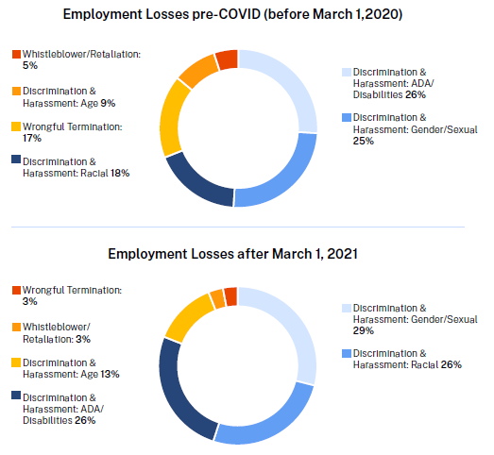
Source: Advisen Nationwide “EPL losses before and after COVID-19” Infographic

EMPLOYMENT PRACTICES LIABILITY
Limit of Liability Distribution for RT ProExec Placements Q1, 2022
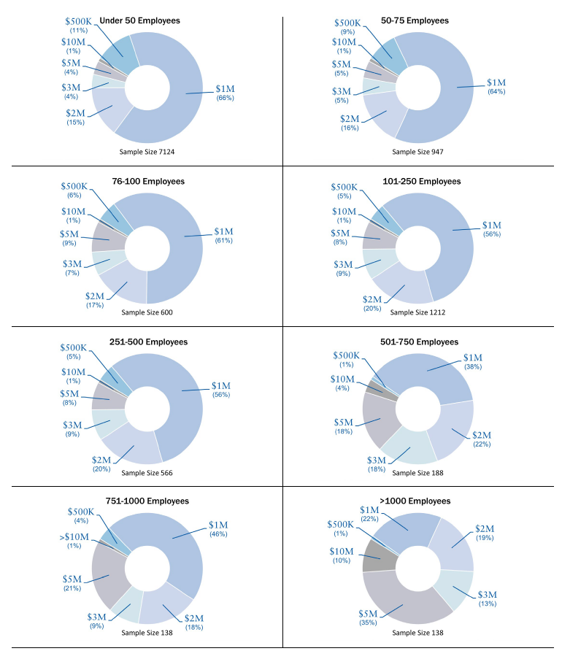

Sample EPL Claims (as provided by E-Risk Services)
Sexual Assault A warehouse worker alleged that she was sexually harassed and assaulted by three successive supervisors. The first supervisor allegedly required her to submit to sexual conduct with him during work hours. When she complained to management, the company fired the supervisor and had her report to the perpetrator’s brother. This new supervisor blamed her for his brother’s termination and sexually assaulted her. Claimant filed criminal charges against the brother who later fled the country. She then was assigned to a third supervisor who allegedly blamed her for the first supervisor’s termination and so treated her poorly.
Settlement and defense exceeded $2.5 million.
Third Party Disability Discrimination A hotel guest alleges disability discrimination in violation of the Americans with Disabilities Act because the guest room, bathroom and front desk were not ADA compliant.
Settled for $27,000 and the hotel agreed to make the necessary changes to become ADA compliant.
Religious Discrimination Four former employees at a manufacturing company filed a lawsuit against their former employer and its coworkers alleging religious discrimination as well as sexual harassment. The plaintiffs allege that their coworkers offended them with sexual comments, unwanted touching and inappropriate jokes. They also allege that the religious organization that the plaintiffs were members in, was disparaged and called a cult. The plaintiffs complained to management who did nothing about it even though the coworkers admitted to "teasing" the plaintiffs.
Settlement and defense exceeded $1.5 million.
EEOC Lawsuit The EEOC filed a class action lawsuit against a company that is alleged to have violated federal civil rights laws by refusing to hire otherwise qualified applicants for outside sales positions because they were female or over the age of 40. The EEOC further alleged that the company engaged in an intentional pattern of systemic hiring discrimination that resulted in no one over 40 or female being hired for seventy new sales representative jobs in a three year span.
Settlement exceeded $1 million along with non-monetary relief consisting of EEOC monitoring for four years, revised hiring practices and extensive training for all employees involved in the hiring process.
Pregnancy Discrimination Shortly after a company is told that an administrative assistant (paid well above market rates) is pregnant with complications, it hires another assistant and has the pregnant claimant train her. After the claimant trains the new employee, the company then fires the claimant. The claimant alleges that her employment was wrongfully terminated based on disability and pregnancy discrimination. She is left without insurance for her pregnancy and can't find a job that pays her anywhere near what her former employer paid her.
Settlement and defense approached $1 million.
Sexual Orientation Discrimination/ Layoff as Pretext A company informed its employee that he was fired because of budgetary reasons. The employee alleges that the layoff was pretext and that he was really fired in retaliation for complaining about harassment based on his sexual orientation. It was further proven that his job was posted online two days before he was fired and shortly after he complained of the harassment.
Settlement and defense exceeded $100,000.
Pregnancy Discrimination An employee who returned from maternity leave felt ill and had to go home after seeing the company nurse. She alleges that her employment was wrongfully terminated based on her disability in that she needed more time off to deal with complications from her pregnancy. Even though the claimant provided a doctor's note for the missing days, as was requested by the company, she was fired anyway.
Settlement and defense approached $500,000.
Disability Discrimination A manager filed a lawsuit against his employer alleging that his employment was wrongfully terminated based on disability discrimination. The evidence indicated that the company did not appropriately engage in the interactive process to reasonably accommodate the plaintiff, but instead fired him while he was out on medical leave. In addition, while the plaintiff was still an employee on medical leave, the company failed to mention him in the application process for a new health care plan which required the disclosure of any employee currently out on disability.
Total settlement and defense exceeded $600,000.
Wrongful Termination An insured gets involved in a bitter dispute with an independent contractor. After the dispute, the brother of the independent contractor who is an employee of the insured is suddenly fired. The employee alleges that the only reason for the termination of his employment was in retaliation for the business dispute the company had with his brother.
Settlement and defense exceeded $200,000.
Negligent Management An employee sexually groped his coworker to the point where she could barely get away from him after the two employees drank excessively while attending an industry function. The next day she complained to management about the incident and that she no longer felt comfortable having their work stations adjacent to each other. Management didn’t take her allegations seriously and only informally reprimanded the alleged harasser.
Settlement and defense exceeded $100,000.
Claim by Founders Husband and wife founders/employees of a medical device company allege breach of their employment contracts in being fired without cause. It was alleged that in a Series “B” Stock Offering two investors were given board representation. These two new board members were extremely aggressive and demanding which drove out long standing board members and senior management. They eventually removed both claimants from the board and later terminated their employment.
Though the amounts owed under their employment contracts were not covered, the defense costs exceeded $2.5 million.

Religious Discrimination Claimant alleges that she was not hired as a teacher based on religious discrimination. After claimant was not offered the job, she found out that the school thought she was qualified yet refused to hire her because of her Mormon faith and the fear that she might impart her beliefs on the children.
Defense and indemnity exceeded $40,000.
Quid Pro Quo Waitress alleges that after she ended a sexual relationship with her manager, he began to harass her and tried to intimidate her into continuing the relationship. When she refused, she received less favorable working hours and was eventually fired.
Defense and indemnity exceeded $100,000.
Retaliation The plaintiff alleges that she had her employment terminated because she testified on behalf of another worker who brought a separate action against the company. Plaintiff alleges that this is a violation of her employment contract which provides that she can only be terminated for good cause. Plaintiff asserts causes of action for wrongful termination, breach of contract and retaliation.
Total defense and settlement exceeded $120,000.
False Representations In a cross-complaint a doctor alleges a breach of his employment agreement. Specifically, he alleges that the company failed to provide him an adequate patient load, office space, the support staff needed to perform his job duties and failed to pay wages. The doctor asserts causes of action for breach of contract, misrepresentation, unfair competition and failure to pay wages.
Total defense costs and settlement exceeded $350,000.
Intentional Misrepresentation An employee is given a percentage of the partnership in an effort to convince him to stay with the company. Subsequently, the employee demands for a distribution of the partnership’s profits and is told that there are no profits. The employee then asks for a bonus based on his partnership shares and is told since he does not share in the “financial risk” that he is not entitled to a bonus. The employee asserts causes of action for: (1) intentional misrepresentation; and (2) tortuous breach of the covenant of good faith and fair dealing.
Total defense costs and settlement exceeded $750,000.
Wrongful Termination An executive of a manufacturing company files suit against the company for wrongful termination and intentional infliction of emotional distress. The plaintiff, a former Chief Operating Officer, makes statements that the company improperly failed to pay an employee overtime and terminated the employee for filing a complaint. The plaintiff alleges that although the company advised him that his termination was due to performance problems, he was actually terminated in retaliation for his honest statements he made in connection with a fellow employee's termination.
Total defense costs and settlement exceeded $750,000.

Wrongful Termination An employee alleges wrongful termination because she shaved her head. The employee contends that all of her performance evaluations were positive and that she was given a salary increase shortly before she shaved her head. The claimant seeks general damages, punitive damages, attorney’s fees and costs.
Total defense costs and settlement exceeded $250,000.
Wrongful Termination An electrician files a complaint against his former employer for wrongful termination. The company instructs him to bill for time for employees that were not actually at the job site. The employee objects to these illegal billing practices. The plaintiff asserts cause of action based upon wrongful termination in violation of public policy
Total defense costs and settlement exceeded $150,000.

Sexual Harassment/Retaliation A female employee working for a service company alleges that several employees made inappropriate sexual comments towards her, including suggestions that she was having a sexual relationship with another employee. In addition, she also alleges that her boss and co-workers asked her inappropriate questions concerning her personal life. The plaintiff alleges that after she complained, her manager engaged in a practice of retaliation. She contends that she was excluded from certain meetings, taken off certain projects and assignments, treated rudely and received a negative evaluation.
The parties participated in non-binding arbitration and consented to a settlement of $250,000.

Discrimination Based on Disability The plaintiff in this case was terminated while out on leave medical leave due to an injury that occurred at work. The plaintiff asserts that he was the victim of numerous discriminatory and harassing actions and remarks regarding his disability. The plaintiff alleges he was advised that if he filed a workers’ compensation claim he would be terminated. The plaintiff was in fact terminated without disability benefits after he filed a workers’ compensation claim. The complaint was comprised of three causes of action; including: discrimination based on physical disability; tortuous termination; and specific violation of state laws.
The defense and settlement exceeded $75,000.

Defamation The plaintiff alleges that her prior company has taken steps to damage her reputation and improperly interfered with her ability to obtain other employment. In particular the plaintiff alleges that the company spoke with several competitors and disclosed the reasons for her termination. The complaint is comprised of several causes of action including: tortuous interference; defamation and wrongful interference with the plaintiffs’ livelihood and reputation; and violation of privacy.
The plaintiff agreed to settle out of court for $125,000 and defense costs exceeded $25,000.
Illegal Employment Practices An employee of a small publishing company filed a charge with the EEOC against her former employer. The claimant alleges that she resigned from her position as office manager because the company engaged in illegal employment practices which made her work environment intolerable. She alleges that the company refused to hire or even consider males for the receptionist position. The claimant also alleges that the owner made degrading comments to a male employee that sat at the receptionist’s desk. The claimant alleges she has been discriminated against on the basis of her gender.
Although the parties settled out of court, the total cost of this claim was in excess of $100,000.
Hostile Work Environment A service company receives a formal complaint from an employee alleging that he was subjected to a hostile work environment and sexual orientation discrimination during his employment. The plaintiff alleges his supervisor made hostile comments about gay people. The plaintiff contends that his supervisor reduced his stock options and sales territory and was treated in a hostile manner during sales meetings. The plaintiff reported these incidents to the President, but that person refused to look into the matter and take any action. The plaintiff was constructively discharged immediately after he complained. The plaintiff alleges six causes of action: hostile work environment, discrimination based on sexual orientation, retaliation, intentional infliction of emotional distress, failure to pay commission and wages, defamation and negligent training and supervision.
The defense and settlement of this case exceeded $300,000.
Sexual Harassment While on a company retreat, an employee claims that he is being stalked and harassed by a company executive. The plaintiff alleges that during the company retreat the executive grabbed his groin and pulled him towards her while in the kitchen area. The claimant alleges that she pinned him against the oven and forcibly kissed him.
The defense and settlement of this case exceeded $400,000.
Sexual Harassment An employee files a complaint with her company that she was subjected to sexual harassment by her manager. The employee alleges that her manager telephones her after work to talk about sex, sent her pictures of himself and propositioned her for sex both during and after working hours.

The defense and settlement of this case exceeded $250,000.

The above claims examples are for illustration purposes only. The policy terms and conditions, including endorsements, will determine the policy’s response to an actual claim.
Fiduciary Liability Insurance

The Employee Retirement Income Security Act (ERISA) imposes various duties on employee benefit plan fiduciaries. Importantly, under ERISA, fiduciaries can be held personally liable for a breach of fiduciary duties. Also of import, ERISA prohibits plans from indemnifying plan fiduciaries, which means that plan assets cannot be used to pay defense costs, settlements, or awards on behalf of fiduciaries.
Fiduciary Liability insurance protects both the corporate entity that sponsors an employee benefits plan, as well as individual plan fiduciaries, against legal liability claims alleging a wrongful act. A “wrongful act” within the Fiduciary Liability context is typically defined as: a breach of fiduciary duty imposed by ERISA; a negligent act, error or omission in the administration of a plan; or another matter claimed against an insured person by reason of their fiduciary capacity. Fiduciary Liability insurance typically covers the legal expenses of defending against a claim, as well as the financial losses a plan may have incurred due to the errors or omissions of, or breach of duty by, a fiduciary.
An important consideration when purchasing Fiduciary Liability insurance is the inclusion of coverage for “settlor capacity” wrongful acts. The sponsor of an employee benefit plan (whether health and welfare or retirement in nature) can “wear two hats”: one as a fiduciary in administering or managing a plan for the benefit of plan participants, and another as employer in establishing, funding, amending, or terminating a plan. Generally, one acts in their fiduciary capacity when exercising discretionary authority over the administration or management of a plan, and in a settlor capacity when making business decisions regarding a plan. Fiduciary functions are governed by ERISA and driven by the best interests of plan participants, whereas settlor functions can involve pursuing the best interests of the company and its shareholders. It is crucial for any Fiduciary Liability policy to include coverage for wrongful acts of insured persons in both their fiduciary capacity and their settlor capacity; otherwise, there may be gaps in coverage.
While an Employee Benefits Liability endorsement to a General Liability policy does provide some protection for administration, it does not provide coverage for breach of fiduciary duty under ERISA or other fiduciary law, which excludes most claims against employee benefit fiduciaries. Breach of fiduciary duty under ERISA is also typically excluded under the D&O and EPL sections of a management liability insurance policy.
Fiduciary Liability insurance may be purchased on a stand-alone basis, or as a shared or sublimit to the D&O coverage. Often, private companies with Employee Stock Ownership Plans owning a significant percentage of the company’s stock will have the D&O and Fiduciary limits tied together for common claims.
Fiduciary Liability insurance is generally very affordable as compared to other liability coverages and is often provided with retention amounts as low as $0 to $2,500, depending upon the number of plans, the total assets in the plan(s), and the types of plans to be covered. However, greater incidence of “excessive fee claims” and related litigation in recent years is driving up the cost of Fiduciary Liability insurance and leading to higher retentions for some insureds.
Excessive fee claims are a type of claim made against fiduciaries responsible for overseeing 401(k) plans, alleging that the fee(s) charged by an outside administrator are substantially higher than the average fee, which is usually stated as a percentage of the total funds held by a given 401(k) plan. Over time, elevated fees can deplete a plan by significant sums, and it is not unusual for employee / plan participant class actions to demand damages in the tens or hundreds of millions of dollars. One way for plan fiduciaries to limit their personal liability for losses to a plan in this context is to understand the fees and expenses charged, and services provided, by outside administrators; evaluate those fees, expenses, and services; and monitor such on an ongoing basis to determine that they are reasonable.
As with D&O and EPL coverage, Fiduciary Liability coverage is provided on a claims-made, and most often duty to defend basis.

Fiduciary Exposures and Claims
Facts About Fiduciary Exposures
ERISA makes plan fiduciaries personally liable to the plan for any losses resulting from breaches of their duties. The Act provides that a fiduciary must make good to the plan any losses resulting from such breach of duty and restore to the plan any profits made by the fiduciary through the use of plan assets. The Act stipulates that civil action may be brought by a participant or a beneficiary for “appropriate relief.” Since ERISA, other laws have also been enacted that impose further obligations upon fiduciaries, including the Consolidated Omnibus Budget Reconciliation Act (COBRA) and the Retirement Protection Act of 1994.
Plan participants and their beneficiaries are not the only parties that can bring claims against fiduciaries; the agencies responsible for enforcing ERISA – the Department of Labor and the Pension Benefit Guaranty Corporation – are also potential claimants. Fiduciary liability claims can include allegations of improprieties in the funding or termination of plans, denial of or changes in benefits, amendments to plan documents, investment of plan assets, benefit calculations or in the selection of investment managers, mutual funds or insurance companies. In addition, civil penalties of 20% of the amount recovered in a settlement with a fiduciary or the amount a court orders the fiduciary to pay back to a plan or its participants may be imposed under ERISA. A fiduciary can also be fined by the Internal Revenue Service for engaging in prohibited transactions.
Basic Fiduciary Duties Owed To a Plan:
Duty of Loyalty, which stipulates that a fiduciary must act solely in the interest of the plan, its participants and beneficiaries and for the exclusive purpose of serving plan- related goals.
Duty of Prudence, which encompasses separate duties of care, skill, prudence and diligence in the management of a plan.
Duty of Diversification in the investment of plan assets. There are, however, certain exceptions to the diversification requirement for “eligible individual account plans” such as Employee Stock Ownership Plans (ESOPs) and profit-sharing plans that permit the investment in company stock in an amount exceeding 10% of plan assets.
Duty to Follow Plan Documents and to discharge all duties in strict accordance with such documents.

FIDUCIARY LIABILITY
Limit of Liability Distribution for RT ProExec Placements Q1, 2022
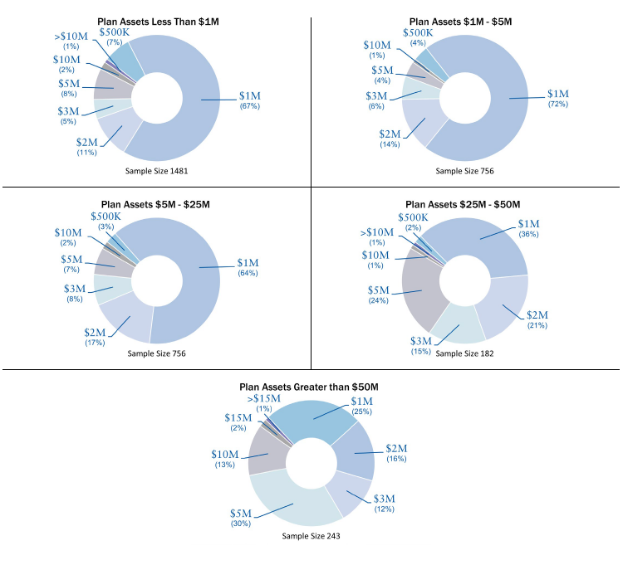


Sample Fiduciary Claims
RT ProExec is a division of R-T Specialty, LLC (RT), a subsidiary of Ryan Specialty Group, LLC, which provides wholesale brokerage and other services to agents and brokers. RT is a Delaware limited liability company based in Illinois. As a wholesale broker, RT does not solicit insurance from the public. Some products may only be available in certain states, and some products may only be available from surplus lines insurers. In California: R-T Specialty Insurance Services, LLC License #0G97516. © 2019 Ryan Specialty Group, LLC

ERISA Violations Plan fiduciaries for a 401(K) plan were notified by the Department of Labor that an investigation had uncovered several violations of the ERISA provisions. Specifically, the fiduciaries were alleged not to have forwarded amounts withheld from employees on a timely basis, improperly allowed the plan to make loans to shareholder-employees, made delinquent employer contributions to the plan, failed to make timely distributions to terminated employees and filed annual Form 5500 reports that falsely indicated that the plan met the minimum funding requirements of ERISA.

Defense and Settlement: $250,000

Imprudent Investment Decisions Fiduciaries of a 401(K) plan were sued by participants for not having divested the plan of an investment selection that generated poor returns and was found to be underperforming a comparable index.

Settled for $250,000 and defense costs exceeded another $150,000.
Administrative Errors The spouse of a plan participant alleged that the participant forged the signature on the spousal release form, which was notarized by the administrator and thus released the spouse’s retirement funds to the plan participant. The spouse sued the plan administrator and the plan sponsor for the spousal pension rights.

Settled for $400,000.

Administrative Errors Two employees approaching retirement age realized that they had never enrolled in the sponsor’s 401(K) plan and sued the sponsor and the plan trustees, alleging that the plan administrator failed to advise them on how to enroll and that enrollment was not automatic.

Settled for $150,000 and defense costs was another $200,000.

The above claims examples are for illustration purposes only. The policy terms and conditions, including endorsements, will determine the policy’s response to an actual claim.
Crime Insurance

Employee theft is one of the largest vulnerabilities of commercial crime, but it’s not the only crime-related exposure that a business face. Forgery, alteration, non-employee robbery or theft of money or securities, money order fraud, counterfeit paper currency fraud, and computer fraud are all other crime-related risks that put your business at an increased exposure for loss.
Companies can protect themselves against such exposures by obtaining crime insurance. Crime insurance can be purchased in different ways. It can be purchased as a stand-alone policy, as part of a commercial package policy, or as part of a management liability insurance (MLI) policy. Generally, when Crime insurance is purchased as part of a commercial package policy, most insurance carriers will cap their limits at $500,000. If purchased on a stand-alone basis or with an MLI package, an insured has the opportunity to purchase much higher limits and negotiate much broader coverage.
The very nature of the types of acts covered by crime insurance often means that the deception is hidden for quite some time. A dishonest employee who is stealing company products or funds will very likely take steps to hide his or her dishonesty. As a result, losses can remain hidden for months, or even years. The longer a crime goes undetected, the larger the ultimate loss may be.
Crime coverage is available in two basic forms: on a “loss discovered” basis or on a “loss sustained” basis. Under a loss discovered form, losses discovered or identified during the policy period are covered by the policy, even if they occurred before the policy period. Under a loss sustained form, losses must be both sustained and discovered during the policy period. Depending on an insured’s circumstances, there are pros and cons to both types of policies.

CRIME INSURANCE
Limit of Liability Distribution for RT ProExec Placements Q1, 2022
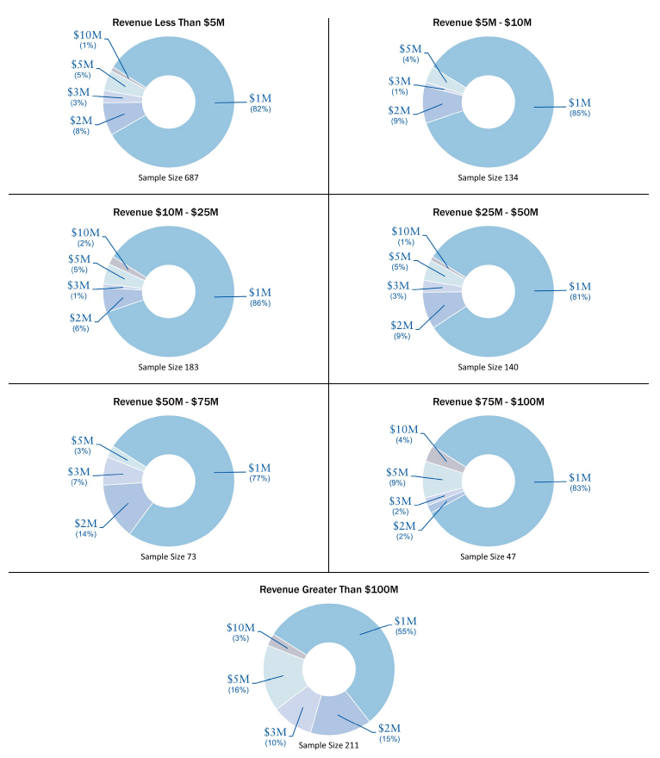

Sample Crime Claims
Phantom Vendor A construction/renovation company’s former tax manager was responsible for making payments to federal, state, and local tax authorities, and he had check-signing responsibility for, as well as access to, the company’s payroll checking account. During his employment, the employee set up a fictitious firm that allegedly provided tax services to the company. The loss wasn’t discovered until after the employee had left the company and was caught doing the same thing to his next employer, at which time he admitted that he had established the phantom company for the sole purpose of stealing from his employer.
Theft of $600,000
Inventory A computer cord manufacturer’s plant manager went on a two-week vacation, during which time the company discovered that its inventory records did not match with shipping and receiving records. After a review, the company found that over 200 pieces of inventory were missing. An investigation concluded that the plant manager and a truck driver had been conspiring for 18 months to place extra pieces of inventory on the driver’s truck. The truck driver then delivered the extra pieces to a buyer who paid the driver cash. The driver and plant manager split the cash payments.
Stolen Inventory of $150,000
Inventory Several cookware manufacturer distributors were relatives of the company’s warehouse manager. They colluded with the warehouse manager to steal cookware out of normal warehouse shipments and sell it at discounted prices to restaurants in a three-state area, while doctoring inventory records to cover the theft. The scheme, which continued for several years, was finally brought to light by an audit and an undercover investigation.
Stolen Inventory of $1 million
Embezzlement The CFO of an environmental firm had full access to his company’s accounts. Over several years, this trusted employee gave himself unauthorized salary increases, bonus checks, and expense allowances. The fraud was discovered when an outside consulting firm conducted a thorough audit.
Embezzlement of $700,000

The above claims examples are for illustration purposes only. The policy terms and conditions, including endorsements, will determine the policy’s response to an actual claim.

